# **World Happiness Report**

## **Introduction**

Happiness has become one of the most important factors in recent years. Since the world is enormously developing, people used to tend to feel more pressure to upgrade their living standards and happiness was placed behind these things. But for now, happiness is considered as the strongest indicator of a country’s social progress. The first World Happiness Report was published in 2012 for the UN High Level Meeting on well-being. This document is the analysis report of World Happiness Index per country from 2015 up to 2020.

## **Insights**

The data source is obtained from the publication of the Sustainable Development Solutions Network, powered by the Gallup World Poll data. The following table shows the top ten happiest countries in the world (2015-2020) ranked by Life ladder scores. It obviously seems that Finland is the most happiness country for four consecutive years. It can also be highlighted that Scandinavia countries occupy in each year.

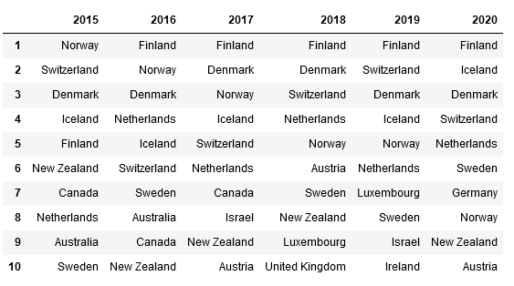

**Table: Top 10 Happiness countries from 2015 up to 2020**

There are 8 factors contributing the ranking of life ladder scores. The following plots shows the relationship between life ladder scores and each factor. It is sad and disappointing fact that generosity has the weakest correlation with life ladder score meanwhile other factors have some degrees of correlation compared to generosity.

|  |  |
| --- | --- |
| C:\Users\Shwe Witt Yee\AppData\Local\Microsoft\Windows\INetCache\Content.MSO\8063D9ED.tmp | C:\Users\Shwe Witt Yee\AppData\Local\Microsoft\Windows\INetCache\Content.MSO\146B093B.tmp |
| C:\Users\Shwe Witt Yee\AppData\Local\Microsoft\Windows\INetCache\Content.MSO\1ECD700E.tmp | C:\Users\Shwe Witt Yee\AppData\Local\Microsoft\Windows\INetCache\Content.MSO\EF0D674C.tmp |
| C:\Users\Shwe Witt Yee\AppData\Local\Microsoft\Windows\INetCache\Content.MSO\DB1E73A.tmp | C:\Users\Shwe Witt Yee\AppData\Local\Microsoft\Windows\INetCache\Content.MSO\C453E358.tmp |
| C:\Users\Shwe Witt Yee\AppData\Local\Microsoft\Windows\INetCache\Content.MSO\646E1B26.tmp | C:\Users\Shwe Witt Yee\AppData\Local\Microsoft\Windows\INetCache\Content.MSO\38DAFA24.tmp |

The following heatmap is the correlation between 8 factors. It can be seen how correlated the 8 variables are with one another.

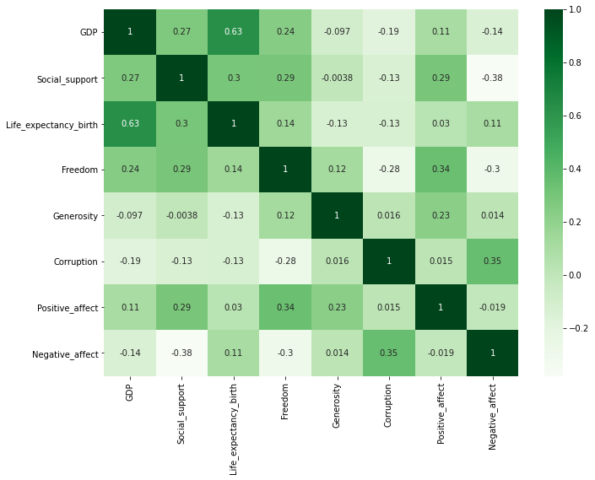

**Figure: Correlation heatmap for the 8 variables**

## **Insight Myanmar**

Surprisingly, Myanmar got first place in terms of generosity in every year except 2018.

Although our country is developing country and has so many unsolved issues, Myanmar people show their kindness and the willing to help the poor by donating money. This fact makes me proud of being a Burmese. The following plots shows the Top 10 most generous countries in years 2015-2020.

|  |  |
| --- | --- |
| C:\Users\Shwe Witt Yee\AppData\Local\Microsoft\Windows\INetCache\Content.MSO\33B0BD48.tmp | C:\Users\Shwe Witt Yee\AppData\Local\Microsoft\Windows\INetCache\Content.MSO\838C3A96.tmp |
| C:\Users\Shwe Witt Yee\AppData\Local\Microsoft\Windows\INetCache\Content.MSO\8789FB14.tmp | C:\Users\Shwe Witt Yee\AppData\Local\Microsoft\Windows\INetCache\Content.MSO\C8CB5642.tmp |
| C:\Users\Shwe Witt Yee\AppData\Local\Microsoft\Windows\INetCache\Content.MSO\6DC50FA0.tmp | C:\Users\Shwe Witt Yee\AppData\Local\Microsoft\Windows\INetCache\Content.MSO\13CE36AE.tmp |

## **Conclusion**

To sum up, it seems like most of the wealthy countries pay less attention in generosity. It would be better happiness scores are more dependent on generosity in coming years. In this exploratory data analysis, Python libraries - Pandas, Matplotlib, and Seaborn are used.